### Southern New Hampshire University

### CS 255 System Design DocumenBairon Gomez

### Professor Eppenger

### CS 255 – System Analysis and Design

February 18, 2023

# CS 255 System Design Document Template

This template lays out all the different sections that you need to complete for Project Two. Each section has guidance to prompt your thinking. You will need to continually reference the interview transcript as you work to make sure that you are addressing your client’s needs. There is no required length for the final document. Instead the goal is to complete each section based on what your client’s needs are. Remove this note when you are finished, and replace all bracketed text with the relevant information.

## UML Diagrams

### UML Use Case Diagram

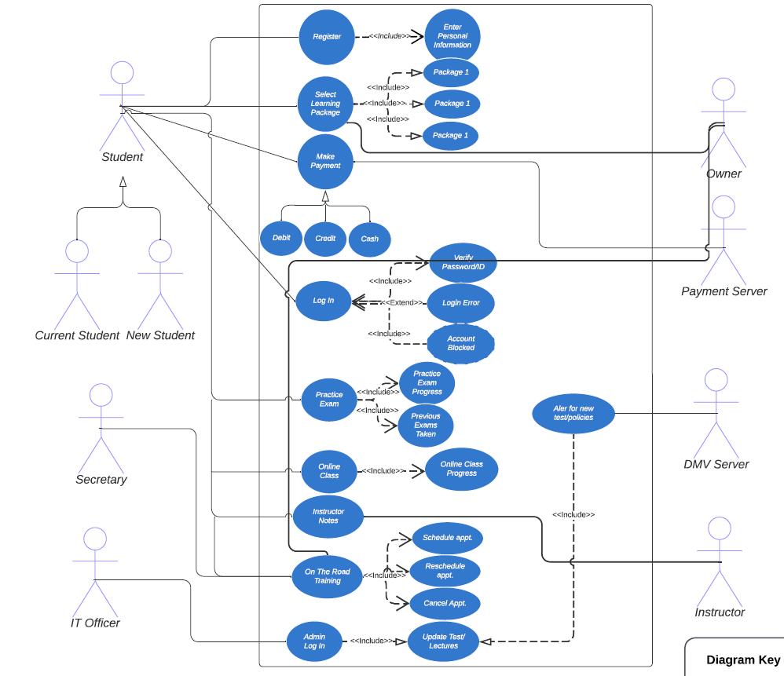

### UML Activity Diagrams

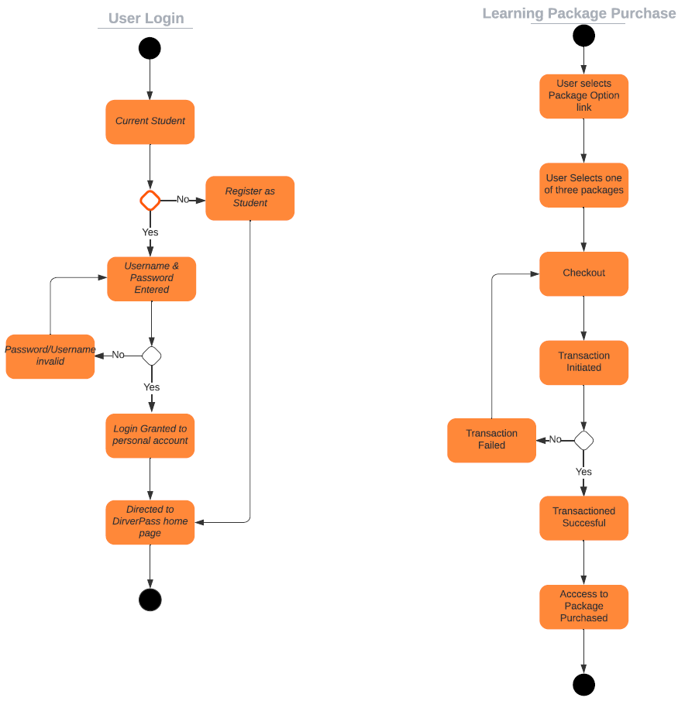

### UML Sequence Diagram

### UML Class Diagram

## Technical Requirements

The system contains different technical requirements that will enable the system to operate and function efficiently as a user navigates through the system. One technical requirement that the system will need is to grant access web enabled devices to use the system. The system must also access the cloud to save the data of users and the system when something is added or removed. Since the system will be using the cloud it will also contain security features to protect the data of the users. Although the security features will be incorporated in the cloud, the IT officer must be notified when an update security update is available to implement the update into the system. The cloud that the developers select to work with must be secure and provide encryption for the client/data server to protect and prevent any unwanted users from entering and corrupting the data in the system. Furthermore, the DMV server should also be able to connect to the DriverPass system to alert the admin of new policies and changes implemented for driving tests. Authentication is also a requirement that will enable the users to sing into their account without enabling others to do so. Lastly, the users will have different access to the system depending on their clearance. The access to the system will be limited based on the role of the user that signed into the system.